Nama : Hafizhan awadh

Nim : 09030582226039

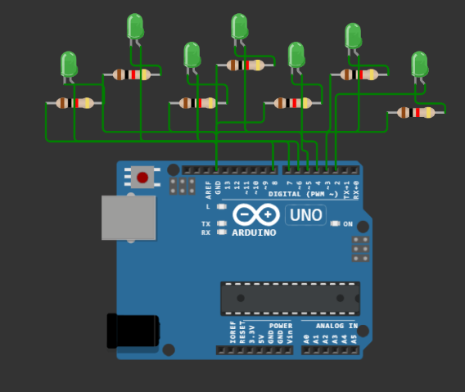

int ledPins[] = {2, 3, 4, 5, 6, 7, 8}; // Pin LED yang akan digunakan

int numLeds = 7; // Jumlah LED

int delayTime = 1000;

void setup() {

for (int i = 0; i < numLeds; i++) {

pinMode(ledPins[i], OUTPUT);

}

}

void loop() {

//1. led akan hidup kelap kelip

blinkled();

// 2. Hidup Barengan

allLedOn();

// 3. Hidup dengan Delay yang Berbeda

LedDelay();

// 4. Hidup Bergantian dari Kiri ke Kanan dan Sebaliknya

rightToleftLeds();

// 5. Hidup bergantian dari redup ke terang

fadeTobrightLeds();

}

void blinkled() {

for (int i = 0; i < numLeds; i++) {

digitalWrite(ledPins[i], HIGH);

}

delay(500);

for (int i = 0; i < numLeds; i++) {

digitalWrite(ledPins[i], LOW);

}

delay(500);

}

void allLedOn() {

for (int i = 0; i < numLeds; i++) {

digitalWrite(ledPins[i], HIGH);

}

delay(2000);

for (int i = 0; i < numLeds; i++) {

digitalWrite(ledPins[i], LOW);

}

delay(1000);

}

void LedDelay() {

int delays[] = {500, 1000, 1500, 2000, 2500, 3000, 3500};

for (int i = 0; i < numLeds; i++) {

digitalWrite(ledPins[i], HIGH);

delay(delays[i]);

digitalWrite(ledPins[i], LOW);

}

}

void rightToleftLeds(){

for (int i = 0; i < numLeds; i++) {

digitalWrite(ledPins[i], HIGH);

delay(delayTime);

digitalWrite(ledPins[i], LOW);

}

for (int i = numLeds - 1; i >= 0; i--) {

digitalWrite(ledPins[i], HIGH);

delay(delayTime);

digitalWrite(ledPins[i], LOW);

}

}

void fadeTobrightLeds(){

for (int i = 0; i < numLeds; i++) {

digitalWrite(ledPins[i], HIGH);

delay(delayTime);

digitalWrite(ledPins[i], LOW);

}

for (int i = numLeds - 1; i >= 0; i--) {

digitalWrite(ledPins[i], HIGH);

delay(delayTime);

digitalWrite(ledPins[i], LOW);

  }

}